# RaiderNAV Focus Group Document

Table of Contents

Welcome 4

Introduction/Background Information 4

Use Case Simulation 5

Creating a Schedule 5

View/Edit Schedule 7

Request/Recalculate Route 8

Disable Notifications 9

Final Impressions/Conclusion 10

Interview Consent Form

I understand that I am participating in a study to determine the demand and usability requirements for a mobile application. I fully understand that my participation in this study is completely voluntary and that I am free to withdraw from the interview at any time without providing a reason. I understand that this interview will be transcribed, and that the transcript for this interview will not identify me by name. I agree that information obtained from me in this interview may be stored and used for the purpose of future research without the need for further consent from me.

I freely and voluntarily consent to participating in this interview.

PARTICIPANT NAME: .............................………..................................................................................

PARTICIPANT SIGNATURE: ...................................................................…

Date: ..............................

Focus Group Script

# Welcome

“We would first like to take this opportunity to thank everyone for helping us out and participating in this focus group. It is our hope to make this as quick and painless as possible for everyone. Please do not hesitate to speak up at any point during this process. Your input as potential users will help us to create a more useful product for everyone.”

“As our first order of business we need everyone to sign a permission form stating that you agree to participate in this focus group and that we may take notes regarding your impressions and comments to be used to improve our app.”

[Have participants sign permission slips]

“Thank you all very much.”

# Introduction/Background Information

“Our inspiration for this project comes from our observations of other students around campus and our own experiences. Texas Tech has a very large campus and, as a result, it is sometimes difficult for both new and returning students to find their way around. This is particularly true when trying to quickly move between classes or attempting to locate a building you are not familiar with.”

“Apps that attempt to address these issues are not currently feasible for Texas Tech students. Google Maps and similar apps provide excellent route generation and generate turn-by-turn directions for the user. However, the app’s ability to do this is predicated on being provided correct physical addresses by the user. Students do not have the time or inclination to locate this information each time it is necessary.”

“Texas Tech provides an alternative option in the form of its own official app. The Texas Tech app provides students with a campus map which allows the user to search for the location of a specific building. Unfortunately, the map is static in nature and will not provide the student with directions nor does it indicate the student’s current position on the map. Furthermore, finding the correct building on the map requires the student to know the building’s name, which may not always be apparent from the building’s prefix, such as is shown on a student’s schedule.”

“Our answer to this problem is RaiderNAV. RaiderNAV is a navigation app specifically tailored to use by Texas Tech students and visitors. The app combines the best features of both traditional navigation apps and a detailed campus map. RaiderNAV will allow the user to input their classes, exactly as they appear on their official schedule, and dynamically generate routing information to each class in the proper sequence. The app will also allow the user to save, delete, and edit multiple schedules. This functionality will allow the user to keep multiple schedules for different days of the week and even from term to term. RaiderNAV will also calculate and display an estimated time of arrival to the next destination to keep students on time. Finally, the app will dynamically remove classes that have already ended from the user’s routing information whenever a route is requested. This behavior ensures proper direction at any given time.”

# Use Case Simulation

“Now that we have introduced RaiderNAV, we would like to present some of the mock-ups we created of the app and go through some typical use scenarios in order to gather feedback from you as potential users.”

## Creating a Schedule

“The first scenario we are going to simulate is creating a schedule.”

[Home Screen Mockup]

“This will be the Home Screen which will pop up as soon as you enter the app. Let’s assume you don’t have any schedules created yet. Select “Create new schedule” to start.”

[Name Schedule Mockup]

“The first step will be to give a name to your new schedule and then start adding classes. After you’ve typed a name for your schedule you would press “Add Class”.”

[Add Class Mockup]

“Here you will be able to add all the details for your class and add it to your schedule. After entering the pertinent information, you have the option to either add another class or finalize the schedule. Let’s assume you’ve added several classes and now choose to finalize your schedule.”

[Schedule Days Mockup]

“This screen will show a summary of all the classes you’ve added to your current schedule. Let’s pretend these samples are the classes you’ve added for your Monday/Wednesday/Friday schedule. Go ahead and select the correct bubbles.”

[Save Schedule Mockup]

“Easy enough. The last step is to press “Create and Save Schedule” to permanently save your schedule.”

“What are your thoughts on the Create Schedule process? Do you have any suggestions?”

|  |  |
| --- | --- |
| Creating a Schedule | |
| Participant Name | Observations/Feedback |
| Participant I |  |
| Participant II |  |
| Participant III |  |
| Participant IV |  |
| Participant V |  |
| Participant VI |  |

## View/Edit Schedule

[Home Screen Mockup]

“Excellent. Now let’s move on and try viewing and editing a schedule you already have saved. As expected, we’ll start again from the home screen. Press “View/Edit Schedule to get started.”

[Select Schedule Mockup]

“As you can see, the system now provides you with a complete listing for all of your saved schedules. From here, you have the option to view, edit, or delete any of them. Let’s pretend John needs to make changes to his Monday schedule. Select it.”

[Edit Schedule Mockup]

“This option presents us with a detailed listing of each of John’s classes on the selected schedule. Course names are entered in a text box so that they can be easily customized to the user desires. Locations are, for ease of use, selected from a drop-down menu. If you need to change the location of an existing course, you will see something similar to this.”

[Edit Location Mockup]

“Selecting the time box corresponding to a particular class provides a similar interface.”

[Edit Time Mockup]

“Here, the user is able to individually alter both start and end times, though not necessarily in the provided increments.”

[Save Schedule Mockup]

“Once a user has finished making changes they would intuitively select “Save” to confirm the changes to their schedule.”

“Thoughts? How do you feel about the View/Edit Schedule Functionality?”

|  |  |
| --- | --- |
| View/Edit Schedule | |
| Participant Name | Observations/Feedback |
| Participant I |  |
| Participant II |  |
| Participant III |  |
| Participant IV |  |
| Participant V |  |
| Participant VI |  |

## Request/Recalculate Route

[Home Screen Mockup]

“Obviously the main objective for RaiderNAV is not just to store schedules, but to use those stored schedules to dynamically generate routing information for the user. Our app makes this quick and easy. Try pressing “View Today’s Classes”.”

[Start Route Mockup]

“It really is that easy. RaiderNAV pulls the correct day of the week, as well as the current time, from the device’s setting for you to generate a route for that day. As soon as the “Start Route” button is pressed, navigation will begin.”

[Recalculate Route Mockup]

“This mockup shows an example of the user’s screen while in route to their next destination. As you can see, the ability to recalculate the route is always available to the user should they veer from the prescribed course.”

“What do think of the navigational portion of RaiderNAV?”

|  |  |
| --- | --- |
| Request/Recalculate Route | |
| Participant Name | Observations/Feedback |
| Participant I |  |
| Participant II |  |
| Participant III |  |
| Participant IV |  |
| Participant V |  |
| Participant VI |  |

## Disable Notifications

[Home Screen Mockup]

“The last scenario we are going to walk-through is the ability to disable notifications for RaiderNAV. We finally get to utilize that last button on the home menu. Go ahead and press “Settings”.

[Settings Page Mockup]

“Here you will see an option labeled “Disable Reminders”. Silencing RaiderNAV is as easy toggling that button. Any future settings/options will also be implemented here.”

“Hopefully turning off notifications is simple enough. Does anyone have any idea for other necessary options?”

|  |  |
| --- | --- |
| Disable Notifications | |
| Participant Name | Observations/Feedback |
| Participant I |  |
| Participant II |  |
| Participant III |  |
| Participant IV |  |
| Participant V |  |
| Participant VI |  |

# Final Impressions/Conclusion

“Our final order of business is to get some feedback from you guys. So, a few questions for everyone.

* Do you think the app effectively addresses the problems that necessitated the creation of RaiderNAV?
* What are everyone’s thoughts regarding the usability of the app?
* Do you have any suggestions or features you would like to see implemented?
* Any questions?”

|  |  |
| --- | --- |
| Final Impressions | |
| Participant Name | Observations/Feedback |
| Participant I |  |
| Participant II |  |
| Participant III |  |
| Participant IV |  |
| Participant V |  |
| Participant VI |  |

“This concludes our focus group meeting for the RaiderNAV app. Again, thank you all for participating. If you have any questions or concerns, please feel free to reach out to us at any time.”

Printable Product Mockups

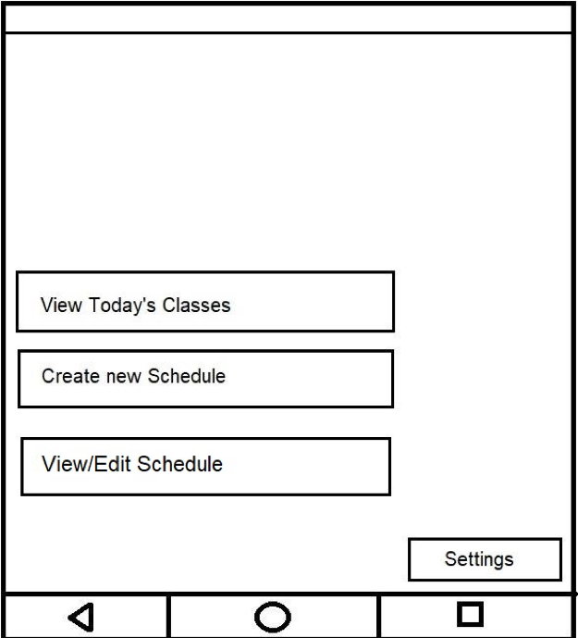

Home Screen

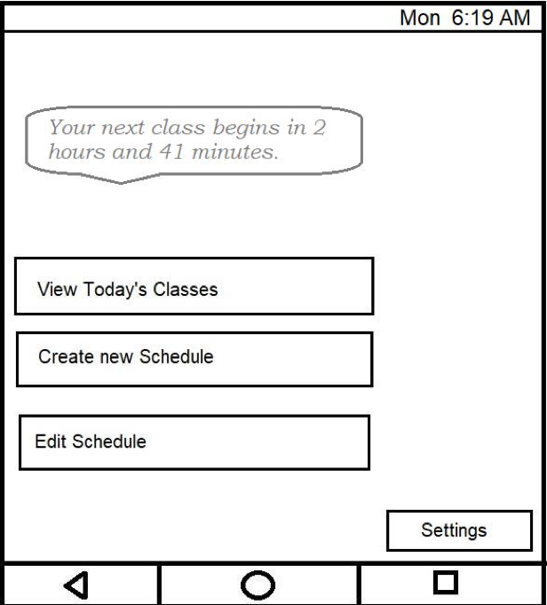

Home Screen (Classes Scheduled)

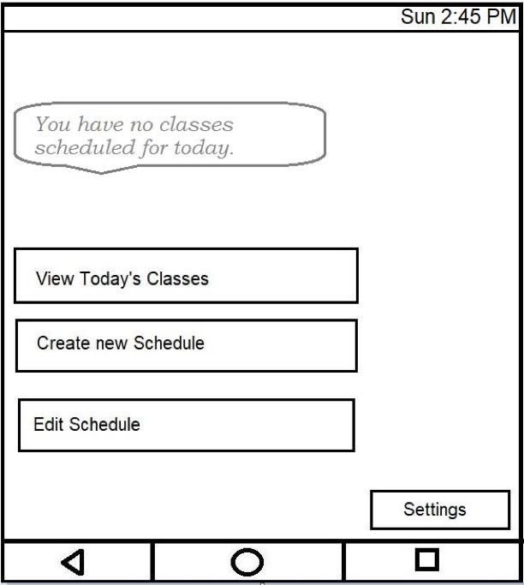

Home Screen (No Classes Scheduled)

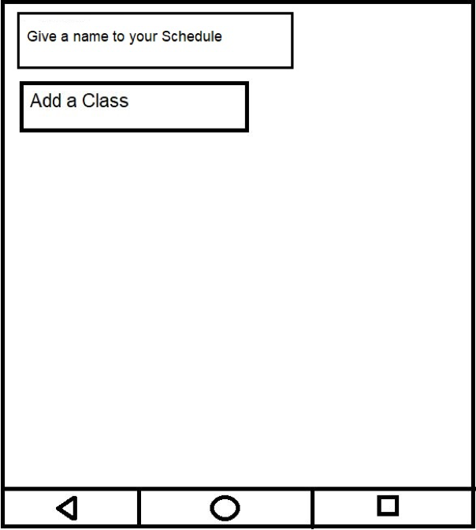

Name Schedule

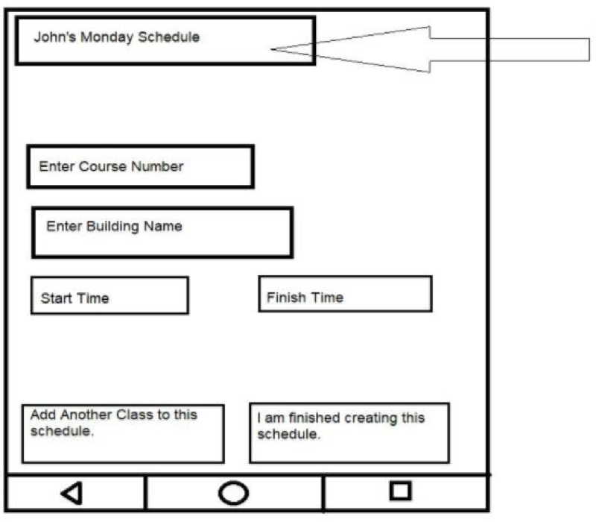

Add Class

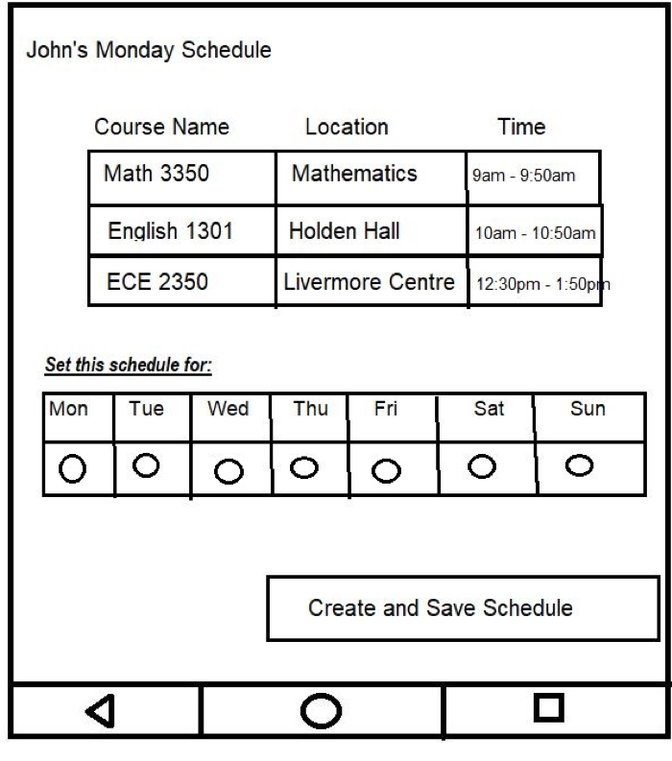

Schedule Days

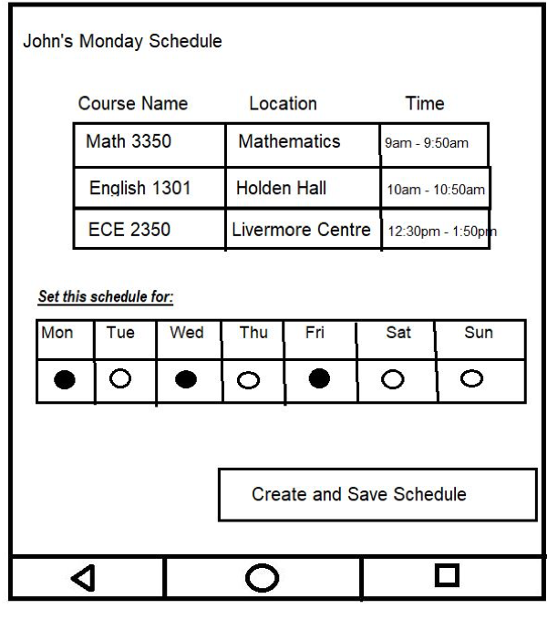

Save Schedule

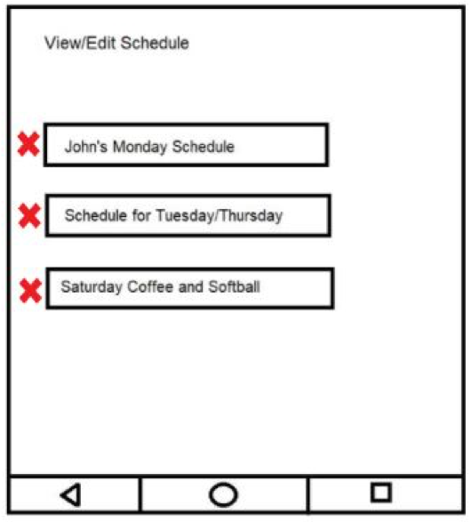

Select Schedule

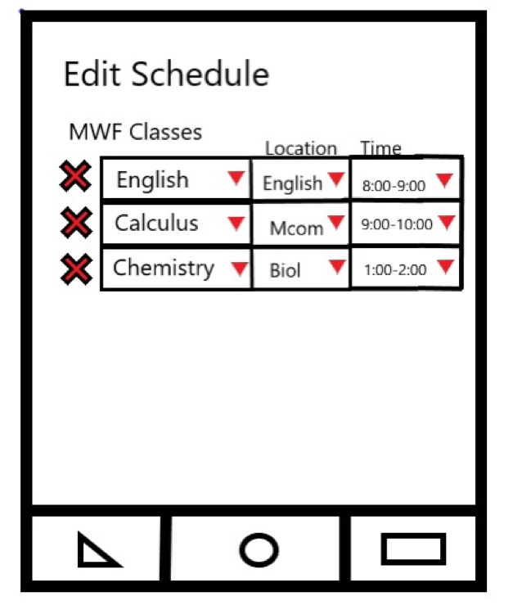

Edit Schedule

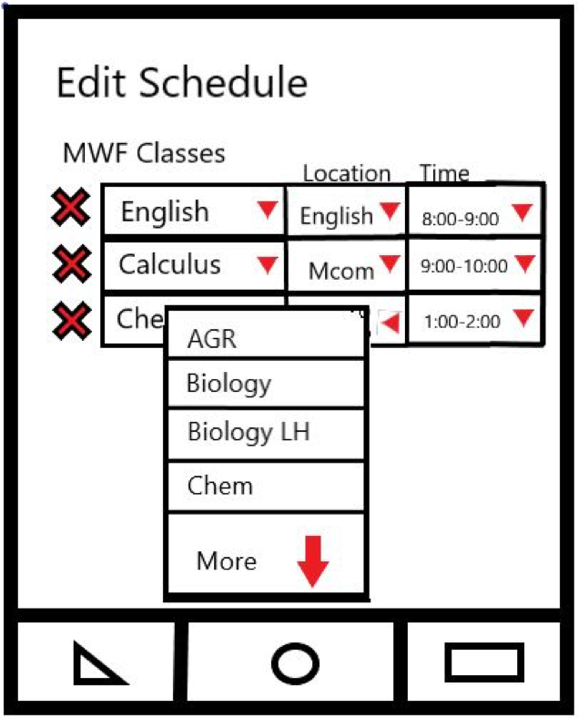

Edit Location

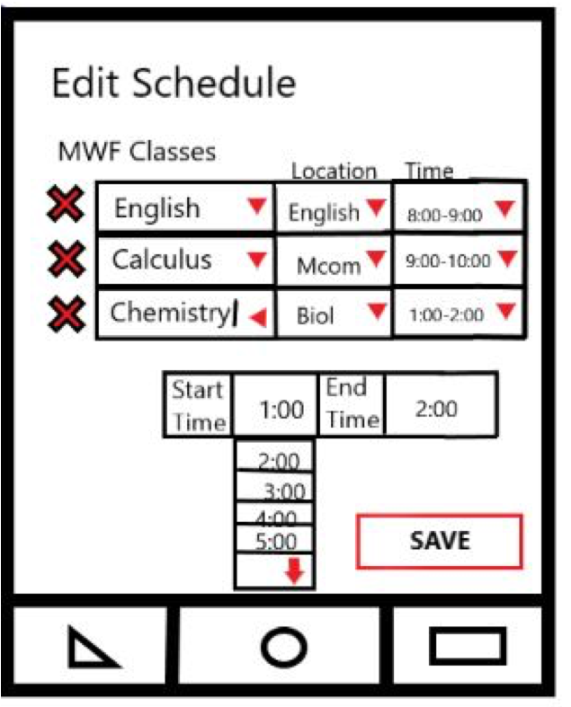

Edit Time

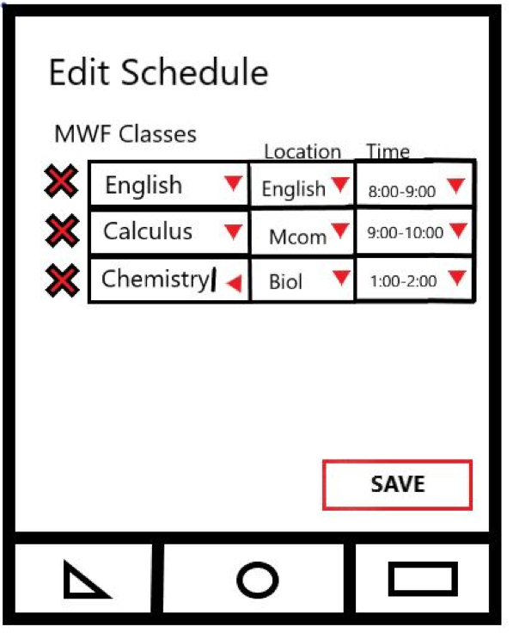

Save Edits

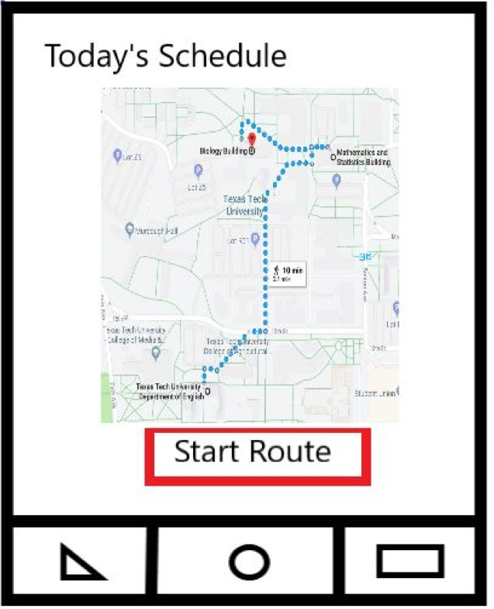

Start Route

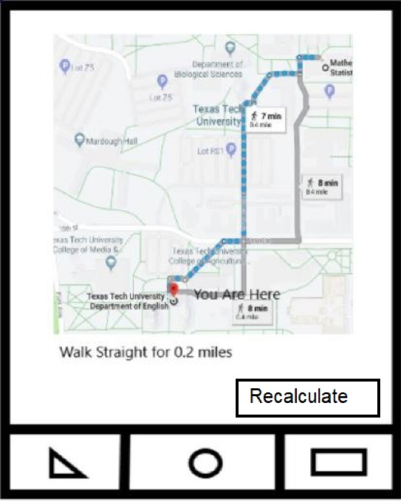

Recalculate Route

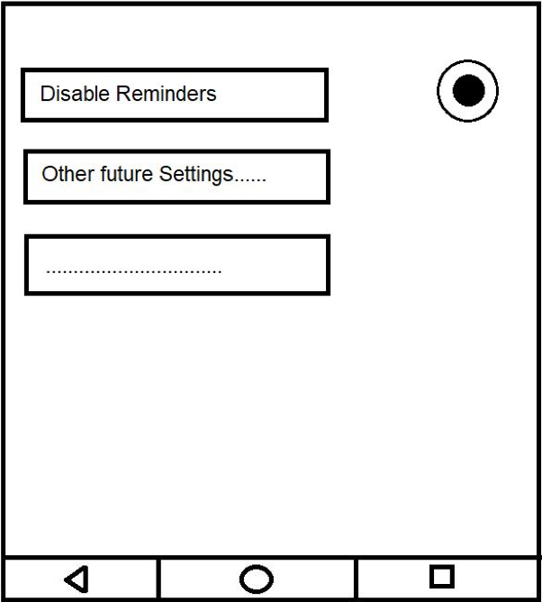

Settings Page